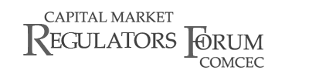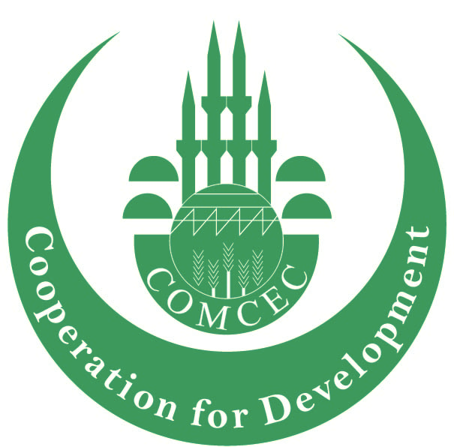

**Hosted by the CMB Turkey - the Secretariat of the Forum**

**COMCEC 1st CAPITAL MARKETS REGULATORS FORUM**

**Draft Agenda**

#### 

#### 26-27 September 2012

#### The Marmara Taksim

#### İstanbul, Turkey

**WEDNESDAY, SEPTEMBER 26TH, 2012**

|  |  |
| --- | --- |
| 08.45-09.15 | **Registration**  Venue: The Marmara Taksim Hotel |
| 09.15-10.00 | **Opening Session** |
|  | Ahmet Vedat AKGİRAY,  Chairman – COMCEC Capital Market Regulators Forum  Capital Markets Board of Turkey  Vice Chair – IOSCO Board  Mehmet Metin EKER,  Director General - COMCEC Coordination Office |
| 10.00-11.00 | **Market Development Task Force**  The world economy has undergone noticeable changes over the past decade, both in terms of the shifting balance of economic and financial power among groups of countries and in terms of structural changes. In this context, applying international standards has become ever more important for all economies. Implementation of international standards requires capacity building for public and private capital market institutions. Capital markets with essential infrastructures are particularly important.  Within this perspective, this Task Force aims to discuss new cooperation and coordination areas to reinforce capital market regulators in order to support financial markets operate effectively for the best interests of the investors and market participants. |
|  | **TURKEY**  Ass. Prof. Dr. Yakup  ERGİNCAN  Director General -Central Registry Agency  <http://www.mkk.com.tr/wps/portal/MKKEN>    **Volunteering COMCEC Capital Market Regulators for Presentation** |
|  | Coffee Break |
| 11.15-12.30 | **Capacity Building Task Force**  Designing policies by regulators has become more crucial and vital in todays complex financial markets structure.  For this reason, coordinated efforts by the regulators to support the capability of human resources to draft and enforce market rules and regulations would be an asset for COMCEC capital market regulators. In this session, the regulatory authorities will pool their ideas for supporting each other’s staff on various topics through training programs. |
|  | **Volunteering COMCEC Capital Market Regulators for Presentation** |
| 12.30-12.40 | **Family Photo Session** |
| 12.40-14.00 | **Lunch**  Venue: Marmara Taksim Hotel |
| 14.00-15.15 | **Islamic Finance Task Force**  Islamic Finance with its growing importance in the global financial system, continues to grab attention of both Muslim and non-Muslim countries with its own features. Islamic financial products and services opens up new prospects for countries and businesses because of the opportunities it offers for all financial and non-financial sectors. Against this background, the participants will be exchanging their views and experience on improving the Islamic Finance and determine the possibilities for cooperation under Islamic Finance Task Force of the Forum. |
|  | **Volunteering COMCEC Capital Market Regulators for Presentation** |
| 15.15-15.45 | **Coffee Break** |
| 15.45-17.00 | **Financial Literacy Task Force**  Since the global financial crisis, financial literacy has become as an important element of financial stability and economic development. There is a consensus that low level or lack of financial literacy may cause challenges for local markets. Financial Literacy Task Force is designed to enhance its members capability to strengthen the financial literacy of various segments of the population.  Therefore, this task force is proposed to improve opportunities to exchange best practices between member state regulators. |
|  | **Volunteering COMCEC Capital Market Regulators for Presentation** |
| 19:30-21:30 | **Welcome Cocktail Reception**  Location: Marmara Taksim Hotel |

**THURSDAY, SEPTEMBER 27TH, 2012**

|  |  |
| --- | --- |
|  | **International Organizations -Financial Co-operation Agenda**  **OECD and IDB** |
| 9.30-10.15 | **International Organisations/OECD and IDB**  **OECD-CMB initiatives at Middle East, North Africa (MENA)**  **and Eurasian Region**  The Capital Markets Board of Turkey and the Istabul Stock Exchange co-operate with the Organisation for Economic Co-operation and Development (OECD) Corporate Governance Committee on improvement of financial markets through corporate governance in the Middle East, North Africa and Eurasia regions. In this session, the OECD MENA Manager at Corporate Affairs Division Ms. Alisa Amico will brief the participants about the establishment of *“Task Force of Middle East and North African Stock Exchanges for Corporate Governance”*and *Eurasia Group on Corporate Governance for Capital Market Development.* The CMB supports these initiatives on the basis of its relations with the regional authorities and its former cooperation with the OECD in the field of corporate governance. |
|  | Alissa Amico - Manager, Middle East and North Africa, Corporate Affairs Division, **OECD** |
| 10.15-10.30 | Coffee Break |
| 10.30-11.15 | **Islamic Development Bank (tbc.)**  **Financial Co-operation and Islamic Finance** |
| 11.15-12.00 | OIC Exchanges Forum Briefing |
|  | OIC Member States’ Stock Exchanges Forum will inform the participants about the recent launch of “S&P OIC/COMCEC Index” in cooperation with Standard and Poor’s (S&P). The Index will include 50 tradable and liquid stocks from the OIC Markets and expected to constitute a basis for financial instruments, and will also address the increasing demand for Islamic financial products. |
|  |  |