|  |  |  |
| --- | --- | --- |
|  | **OIC MEMBER STATES’ STOCK EXCHANGES FORUM 6th MEETING & IIFM SEMINAR** |  |

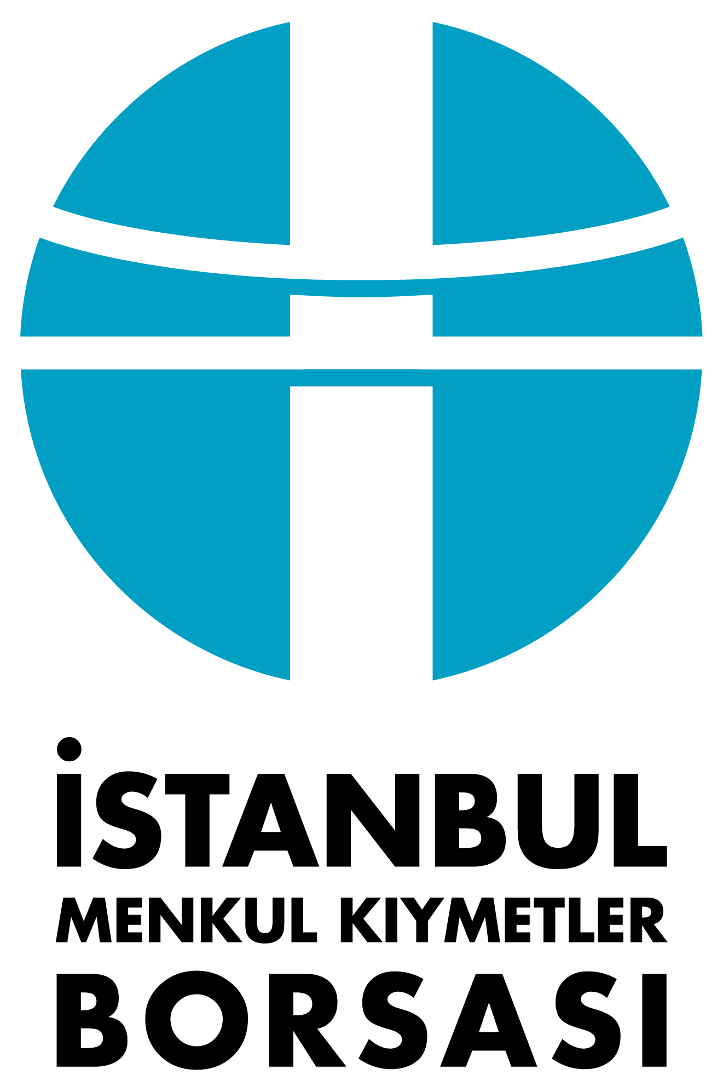

**Wednesday, September 26, 2012**

**The Marmara Hotel, İstanbul**

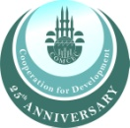



**Draft Agenda**

|  |  |  |  |  |
| --- | --- | --- | --- | --- |
| **08:30-09:00** | | **Registration** | | |
| **09:00-10:00** | | **Opening Remarks** | | |
|  | |  | *Mr. İbrahim M. Turhan, Chairman and CEO, İstanbul Menkul Kıymetler Borsası* | |
|  | |  | *COMCEC Coordination Office\**  *Mr. Vedat Akgiray, Chairman, Capital Markets Board of Turkey\**  *OIC Representative\** | |
| **10:00-10:15** | | **Coffee Break** | | |
| **10:15-12:15** | | International Islamic Financial Market (IIFM) Seminar  “Collateralization and Tri-party arrangement for domestic and international Islamic instruments” | | |
| **12:15-13:45** | | Lunch | | |
| **13:45-15:00** | | Working Committee Meeting | | |
| **15:00-15:15**  **15:15-16:15**  **16:15-17:30**  **19:30-23:00** | Summary of the Forum activities and future plans, *Mr. İbrahim M. Turhan, Chairman & CEO, İstanbul Menkul Kıymetler Borsası*  Presentation by the Project Group on Capital Market Linkages  Presentation by the [Task Force for Customized Indices and Exchange Traded Islamic Financial Products](http://www.oicexchanges.org/taskforces/taskforces.htm#Task1#Task1) and Open Discussions (TF Leader: IMKB)  Q&A Session  Coffee Break  “S&P OIC COMCEC Index”, The Way Forward after Launch  Q&A Session  Drafting of Decisions and Final Report  Closing Remarks  Gala Dinner | | |
|  | |  | | |
|  | |  | | |
|  | |  | | |

* To be confirmed